Kaarel Part

Documentation for the design portion of the Nea coursework
Design
Computer Science NEA

Contents
Decomposition 3
Visual map of the system 3
Explanation of each part in the system 3
Inputs, outputs and processes. 4
User Interface 6
Login screen 6
Wrong email 6
Invalid credentials 6
Main dashboard 7
with a booking 7
Rooms list page 8
My bookings 8
create a new booking 9
Select a room 9
Select dates 10
Booking details 10
Support page 11
Admin dashboard 11
Data structure 12
Methods of Access 12
Database design - ERD 13
Data Dictionary 13
Employees 14
rooms 14
bookings 14
admins 15
supporttickets 15
Validation 15
Validation for DB 15
Validation inside the python codebase 17
Algorithms 18
User Authentication Algorithm 18
Room Booking Conflict Detection Algorithm 19
Booking Validation Algorithm 19
User Creation Validation Algorithm 20
Room Creation Validation Algorithm 20
Authorization Check Algorithm 21
Support Ticket Assignment Algorithm 21
Room Availability Search Algorithm 22
User Session Management Algorithm 22
Booking Cancellation Algorithm 22

Decomposition

Visual map of the system
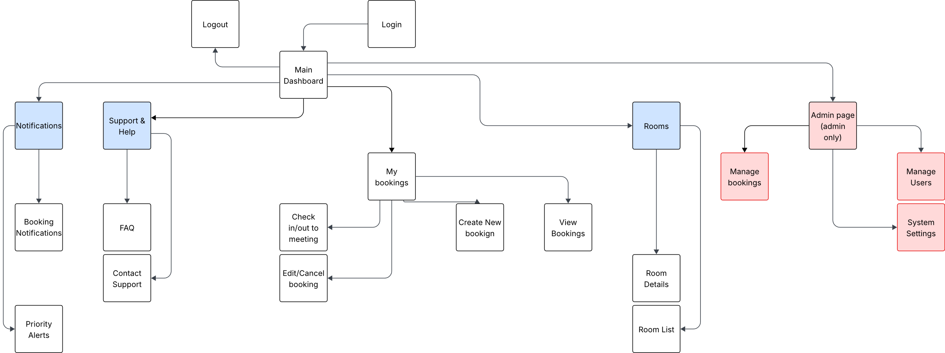

Explanation of each part in the system
Main Dashboard - Main Home page for the entire system required to be able to have a place where the user can actually access the software.
My bookings – main dashboard for letting the user see their bookings. Required for the user to be able to both be able check their meetings and to join or modify a meeting/booking they’re in. The system would not be able to work without them having access to their meetings
Rooms – main dashboard for seeing every room in the building. Required so the user wouldn’t need to either walk around the building to see what is available and what is not. Also, so that the system can also have a digital version of the room it can link to and manage.
Notifications – A way to let the user know on updates on meetings they’re involved in / no longer involved in. This is kind of optional since I also have a smtp server running along that will send an email to the however having it all in one dashboard makes it a lot nicer for the user. Also, its provides redundancy if for some reason the server ever goes down.
Admin page (admin only) – A dashboard for managing the entire system, given only access to the current administration team in place. Pretty much required if I would like to have special case scenarios be done digitally and also to fix small problems in the system on the fly without having to fix it in code and then redeploy.
FAQ – A basic frequently asked questions page if the user has any problems. This is needed to reduce any basic problems that can be solved by just reading this page instead of having to annoy other employees or the administration team or maintainers.
Contact Support – Give a digital way to contact administration or support team. Sure, email already exists but having an in place way to contact the team makes it easier to avoid any problems other services may have e.g. email server down or teams down etc. Also as said before it allows for a way to have everything in one place to reduce fragmentation problems as much as possible.
Room List – A way to see every room in the building. Required so that the user can see what is available and what isn’t and what types of rooms are available.
Room Details – as said above a way to see more information about the room e.g. next time booked, what type of equipment is in the room, how many seats are available in the room. Required so that the user can find the perfect room for their meeting
Logout & Login– Way to leave and enter the system. Required to have users since it allows for each user to have their meetings separated from other employees.
Booking Process – The way to create a booking. Required so that the user can create a booking inside the system.
View Bookings – a way for the user to see what bookings they’re a part of. Required so that the person knows what they’ve been registered to and where they need to go.
Edit/Cancel booking – A way to manage the bookings they’re a part of. Required so that the user can change details about the booking if the circumstances have changed around it.
Check in/out to meeting – A way for the user to be able to let the system know and also anyone connected to it that they have joined or left the meeting. Required so that the system and anyone using it can know where anyone is when inside the building and also for the system to be able to set a room as occupied if it’s taken up.
Booking Notifications – Notifications for the user if a booking is about to start. This is more like an alert than a notification and its required since it gives a final reminder for the user/employee that they have a meeting happening shortly to prevent people being missing or late due to them forgetting about a meeting.
Support & Help – A main page for letting the user read or contact support. Required to have a way to have all the support in one place.
Priority Alerts – A way to have an alert instead of a notification for the user about a booking. Mainly required so that extra important meetings like a guest from a tech company introducing their new product with a large group of people joining so that everyone in that meeting will know that it’s happening. This is mainly used by the Administration team to set since these will be meetings that override typical user meetings.
Manage bookings – Let the Administration team manage bookings of the users. Required to manage special case bookings to be able to fix it within the system.
Manage Users – Allow the administrators to remove/edit/add users to the system. Required so removing people who have left the authority is possible or adding new employees to the system. This will also allow for password/email/general details to be changed.
System Settings – A way for admins to change some system settings on the fly. Required so that e.g. changing domain of email address or email server etc. possible to be changed without having to change the code and redeploying the system.

Inputs, outputs and processes.
Sub Problem Ref | Input | Process | Output
User Authentication | Employee ID and password (login credentials) | Validate credentials against database; assign role (staff, admin, manager) | Secure access to system with correct user permissions
View Room Availability | User request (date, time, room filters) | Query database for real-time availability | Display available/unavailable rooms instantly
Make a Booking | Booking form input (date, time, room, employee ID) | Validate form, check for clashes, store booking in database | Booking confirmation and updated schedule
Cancel/Amend Booking | User request to edit/cancel | Verify user rights, update/cancel booking record in database | Updated schedule + automatic notifications
Check-in to Meeting | Employee ID/NFC scan at room screen | Match scan to existing booking, update room status | Confirmation message + log of attendance
Manage Overruns/Buffer Time | Meeting end time vs actual check-out | Apply buffer (up to 60 mins); update room readiness status | Room marked available/unavailable accordingly
Manager Override | Manager booking request conflicting with existing booking | Check manager role + justification; override lower priority booking | Priority booking added, with record of override
Search & Filter Rooms | User input (tags: capacity, equipment, etc.) | Search database using filters | List of matching rooms with details
Notifications | Booking changes (create, cancel, amend) | Trigger SMTP (Mailjet) email sender | Automatic email alerts to all relevant parties
Admin Oversight | Admin query for system status | Retrieve logs of bookings, overrides, cancellations | Dashboard of system usage and activity logs
Data Security & GDPR Compliance | User requests/booking data | Restrict access by role, anonymise non-essential details | GDPR-compliant data handling and storage
System Reliability | Database queries, user actions | Implement validation, error handling, backups | Stable, fault-tolerant booking system

User Interface

Login screen
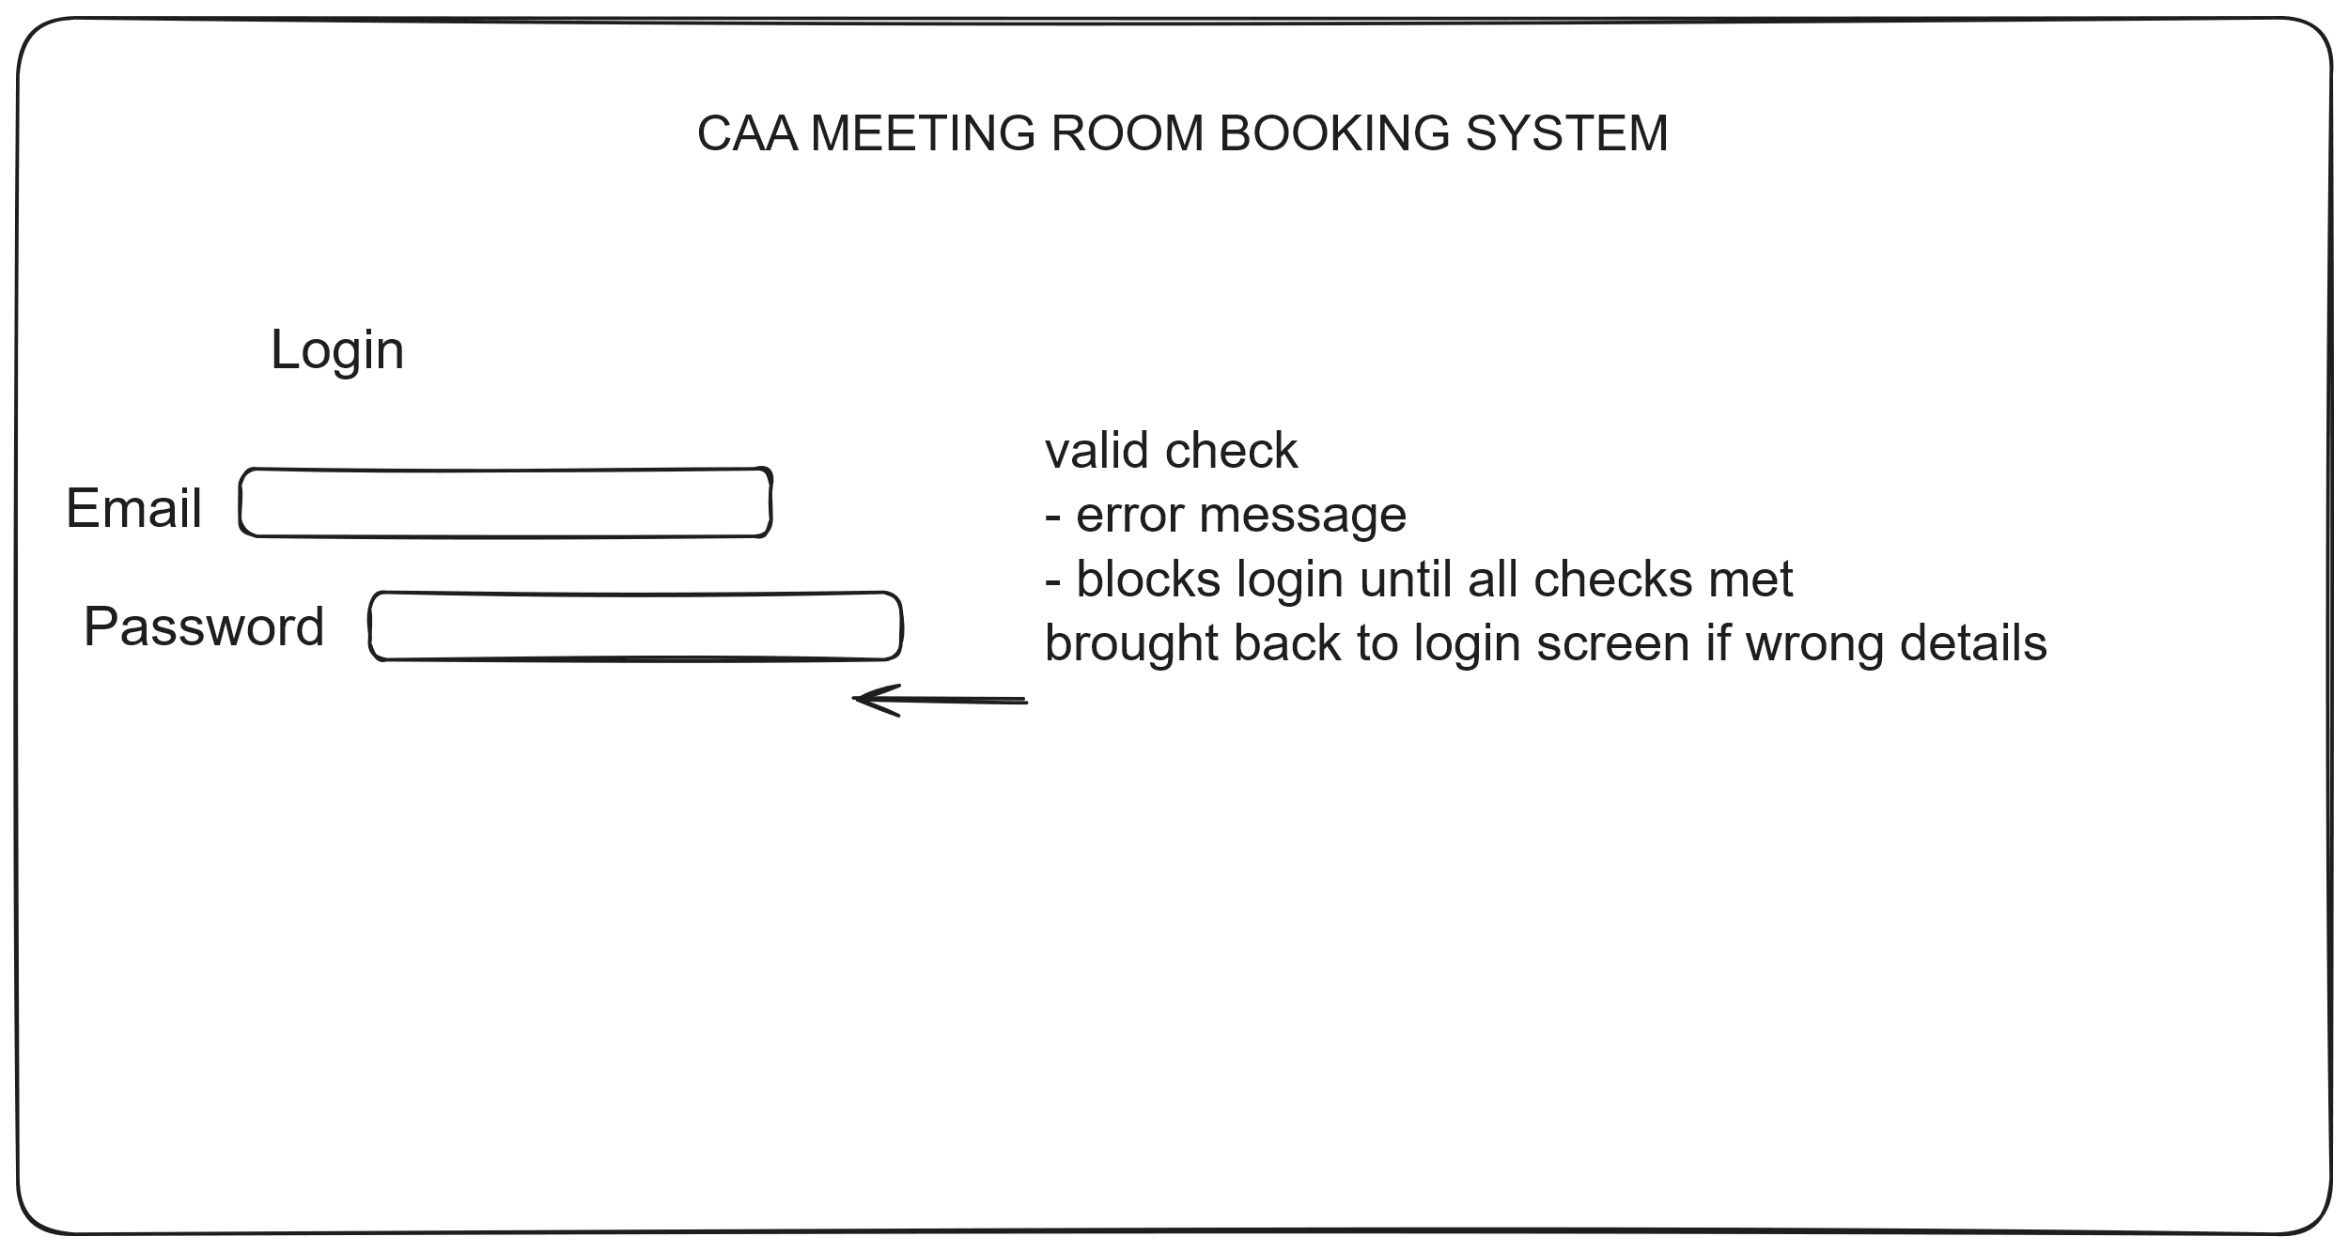

Main dashboard
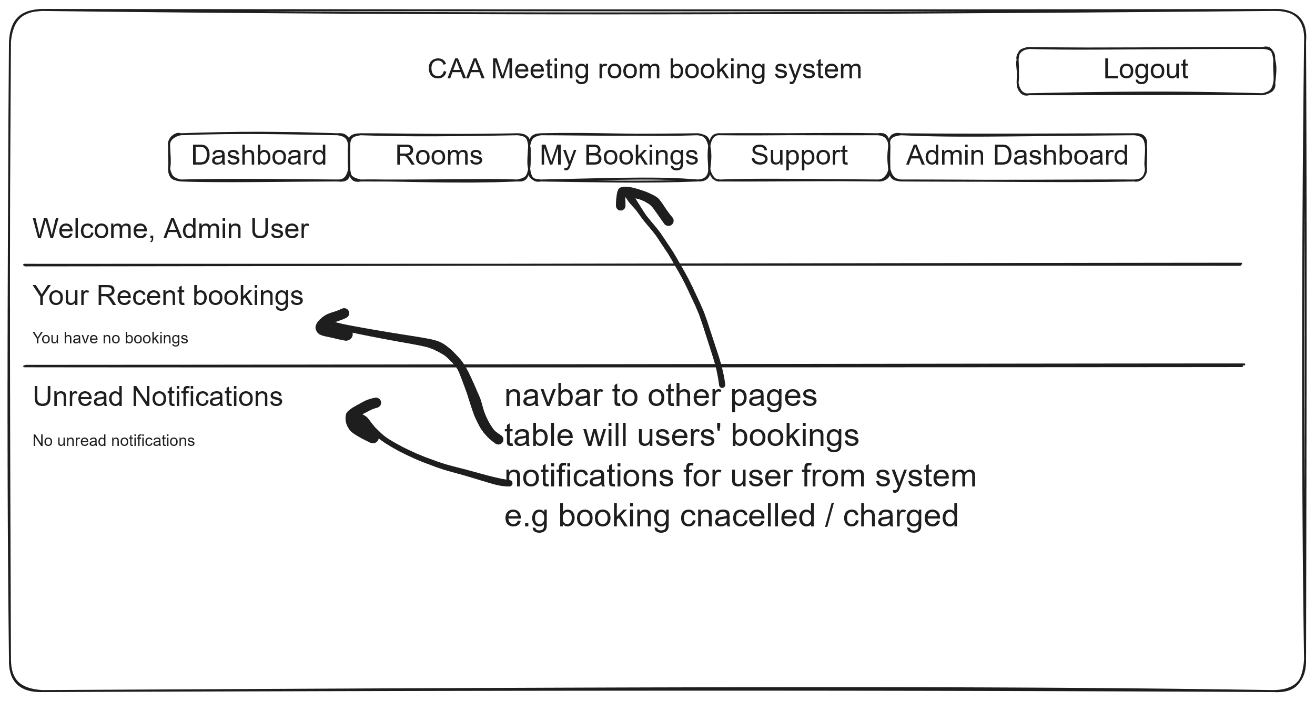

Rooms list page
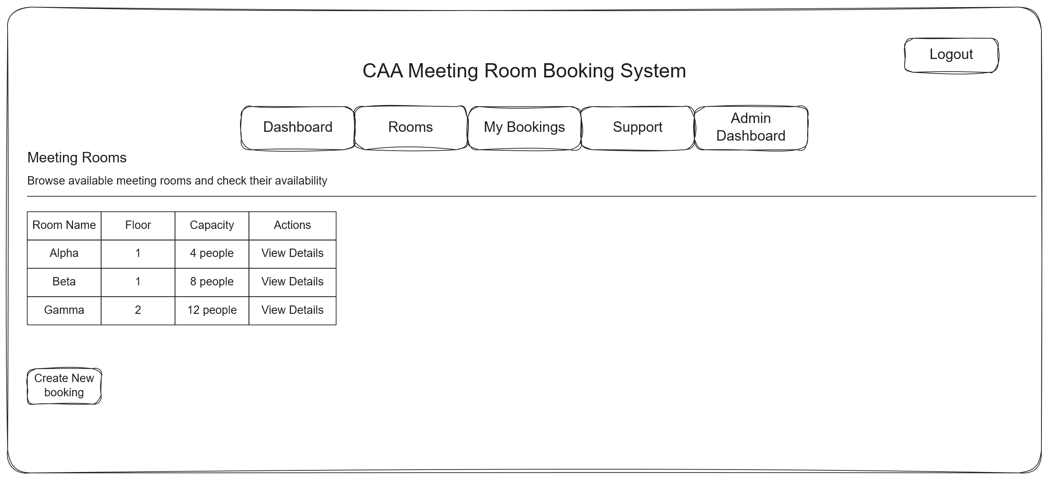

My bookings
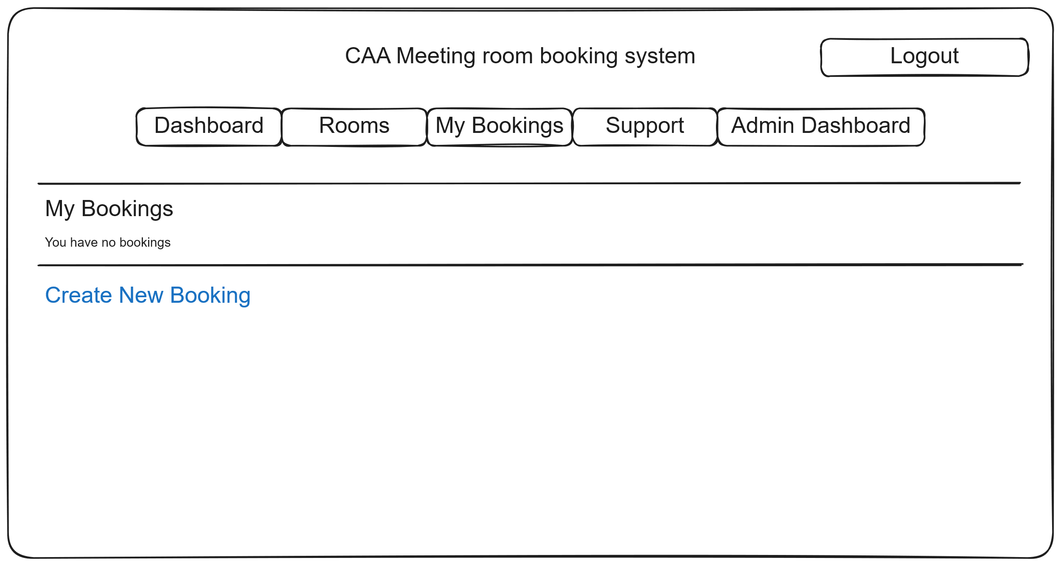

create a new booking
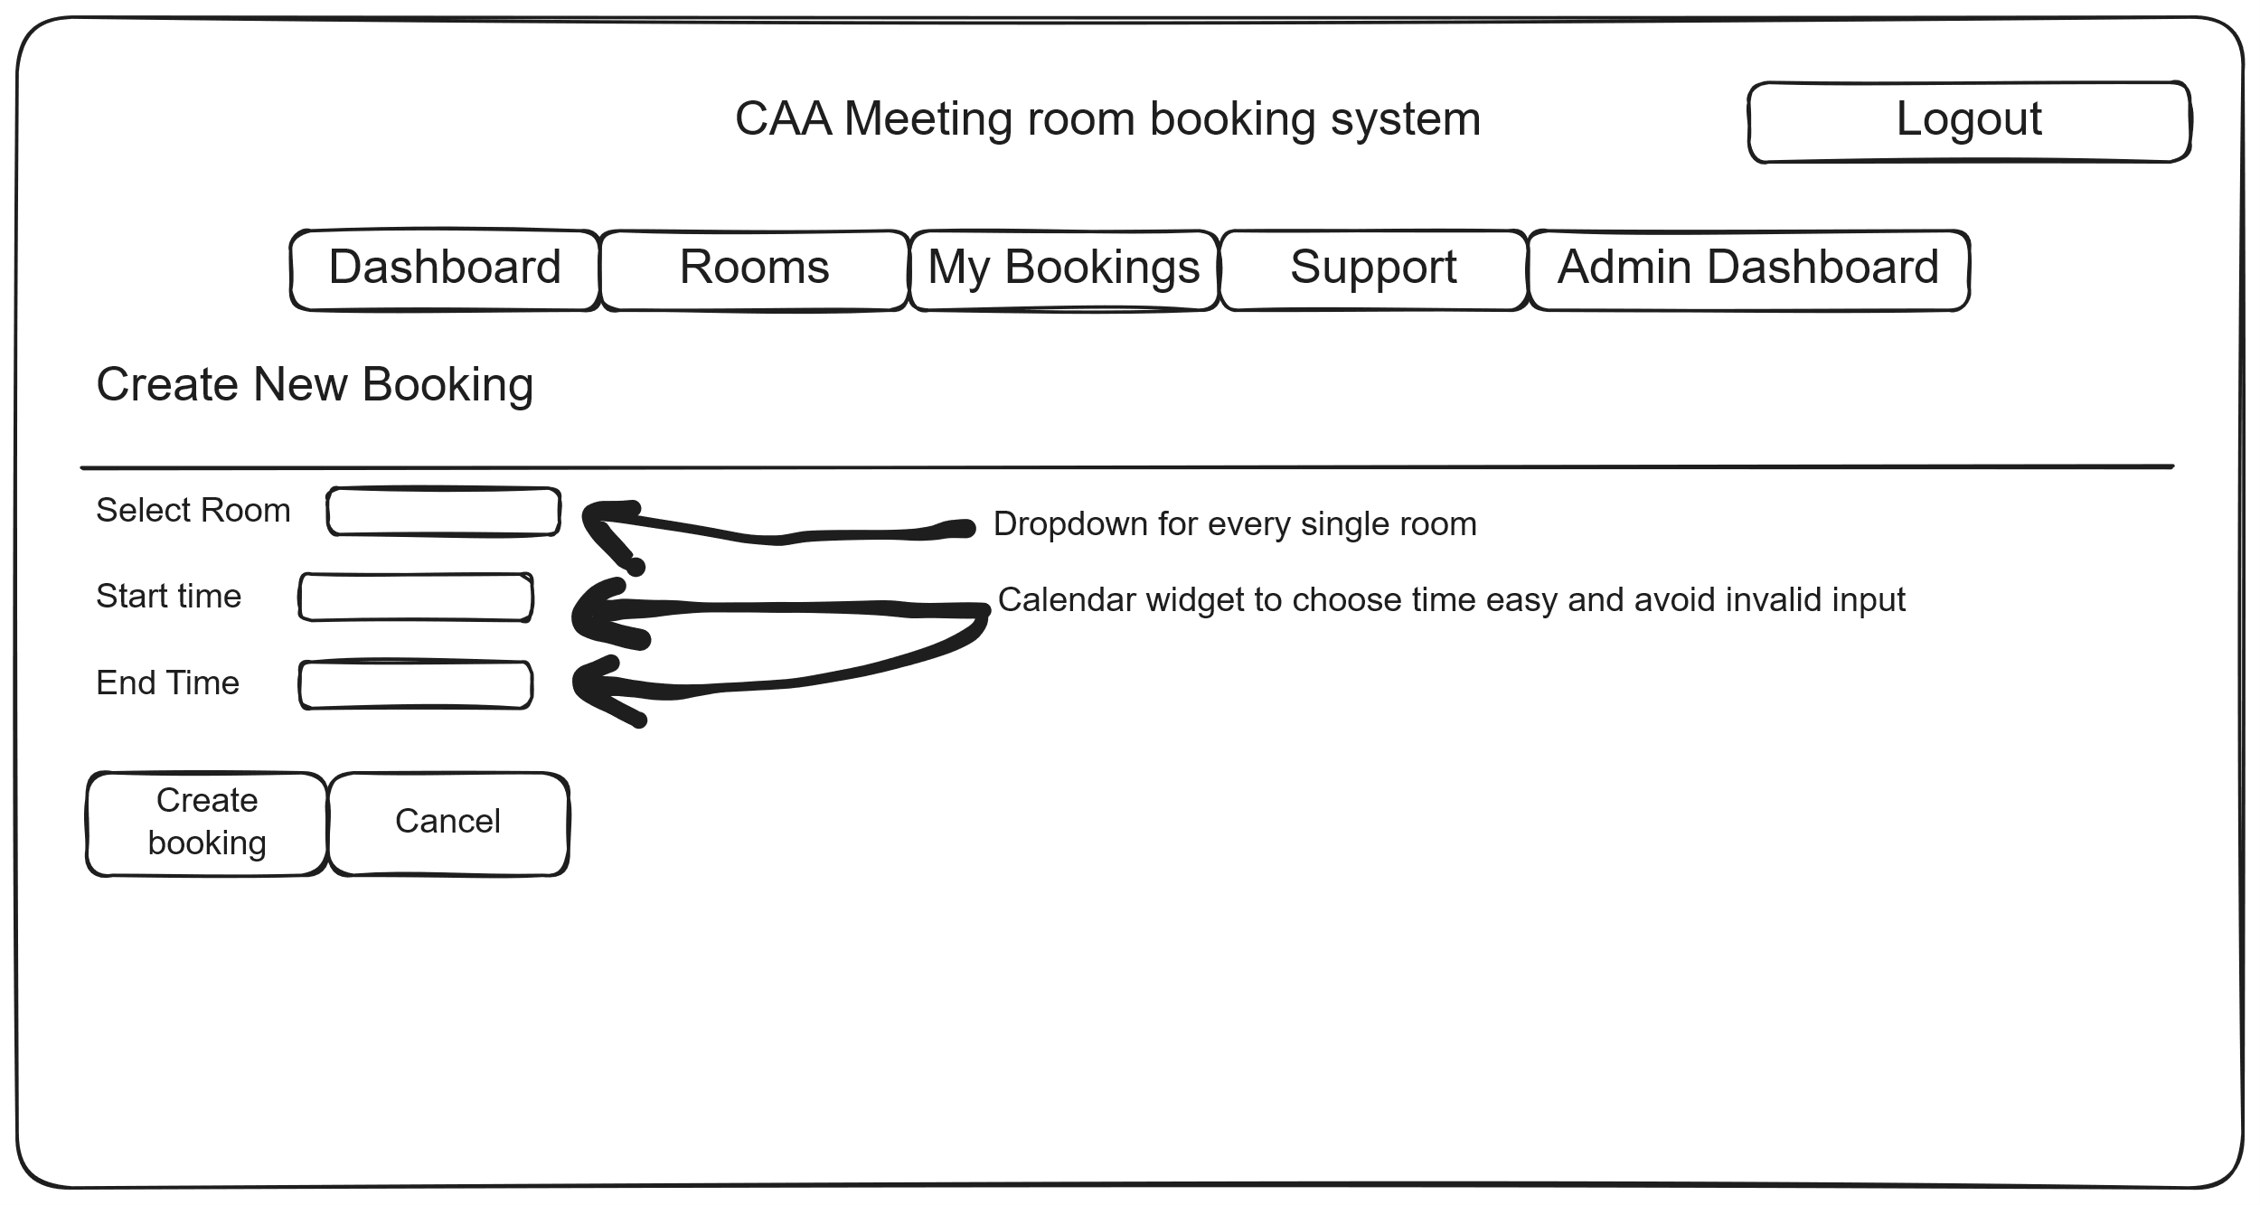 -

Booking details
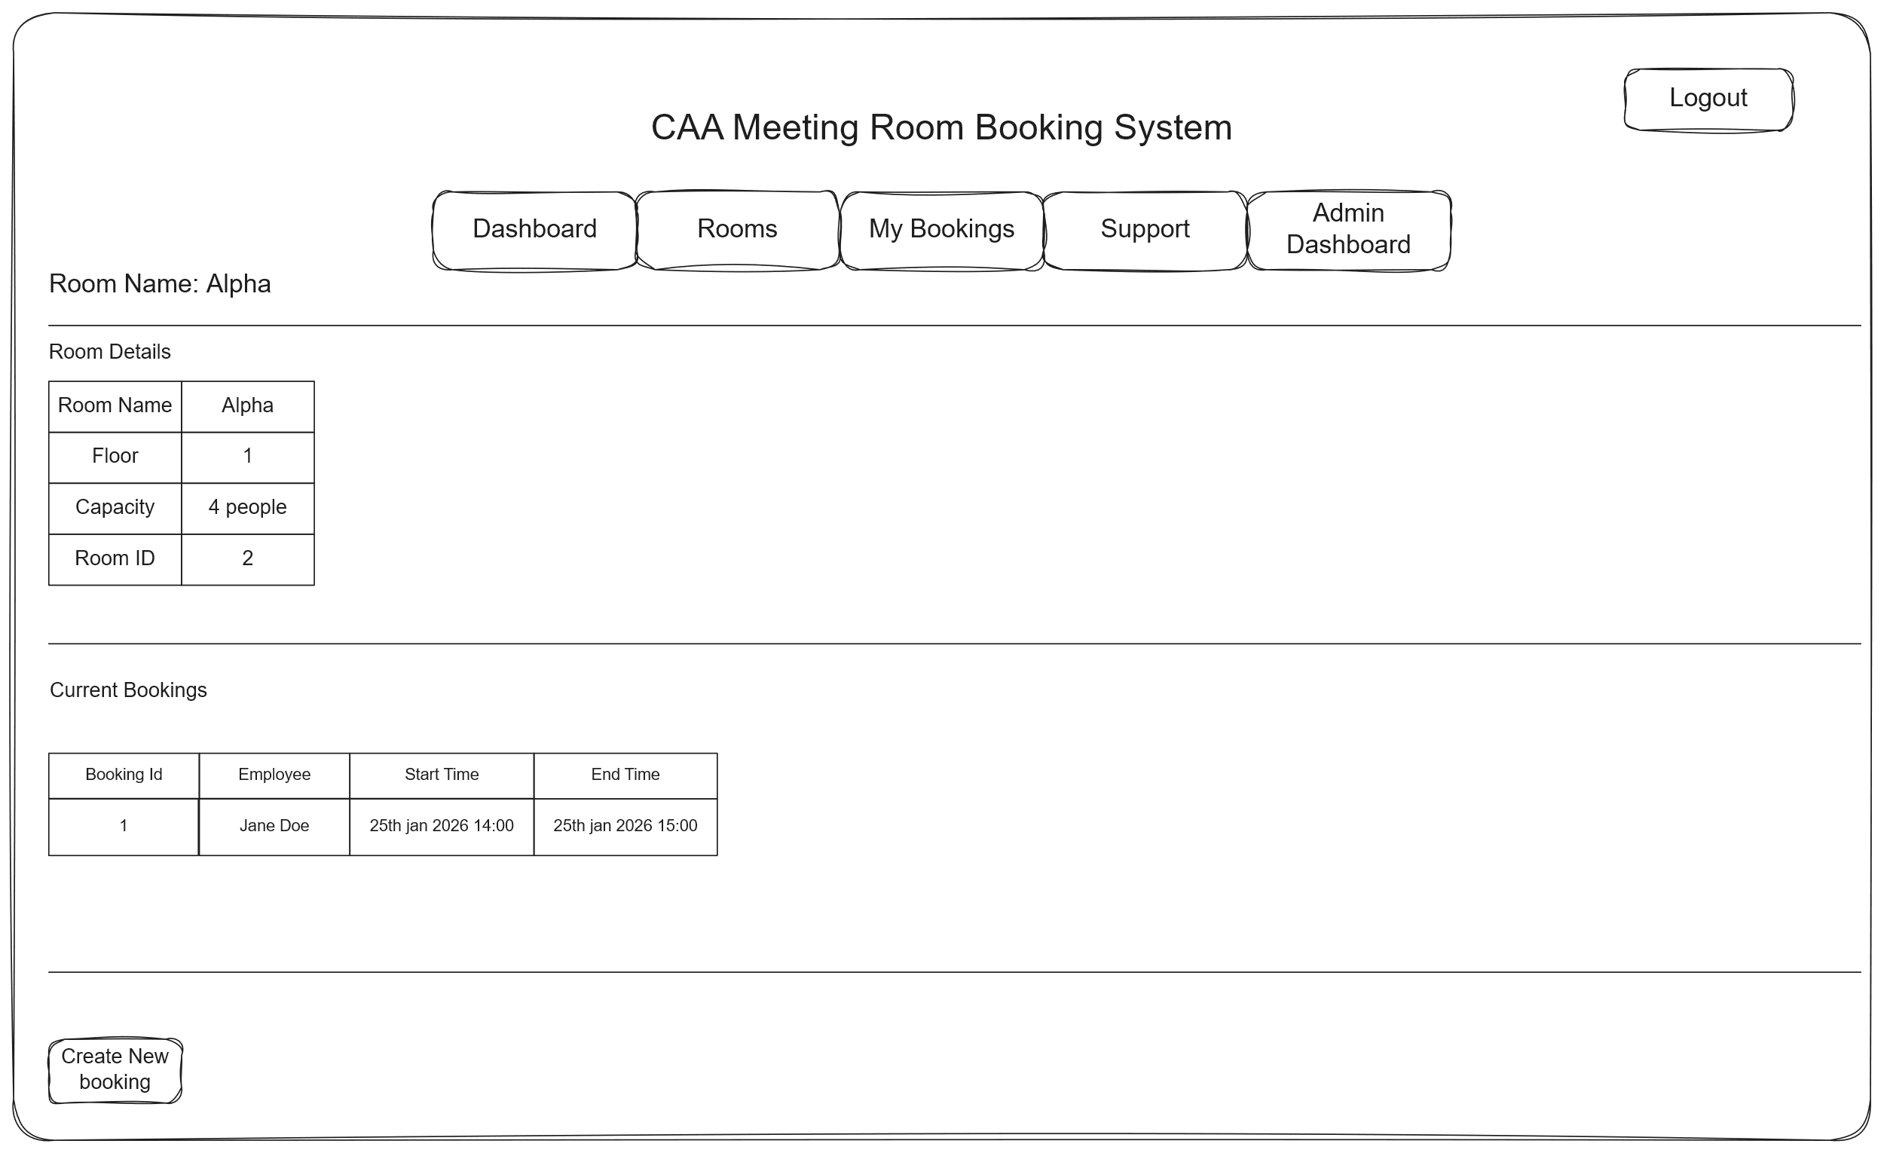

Support page
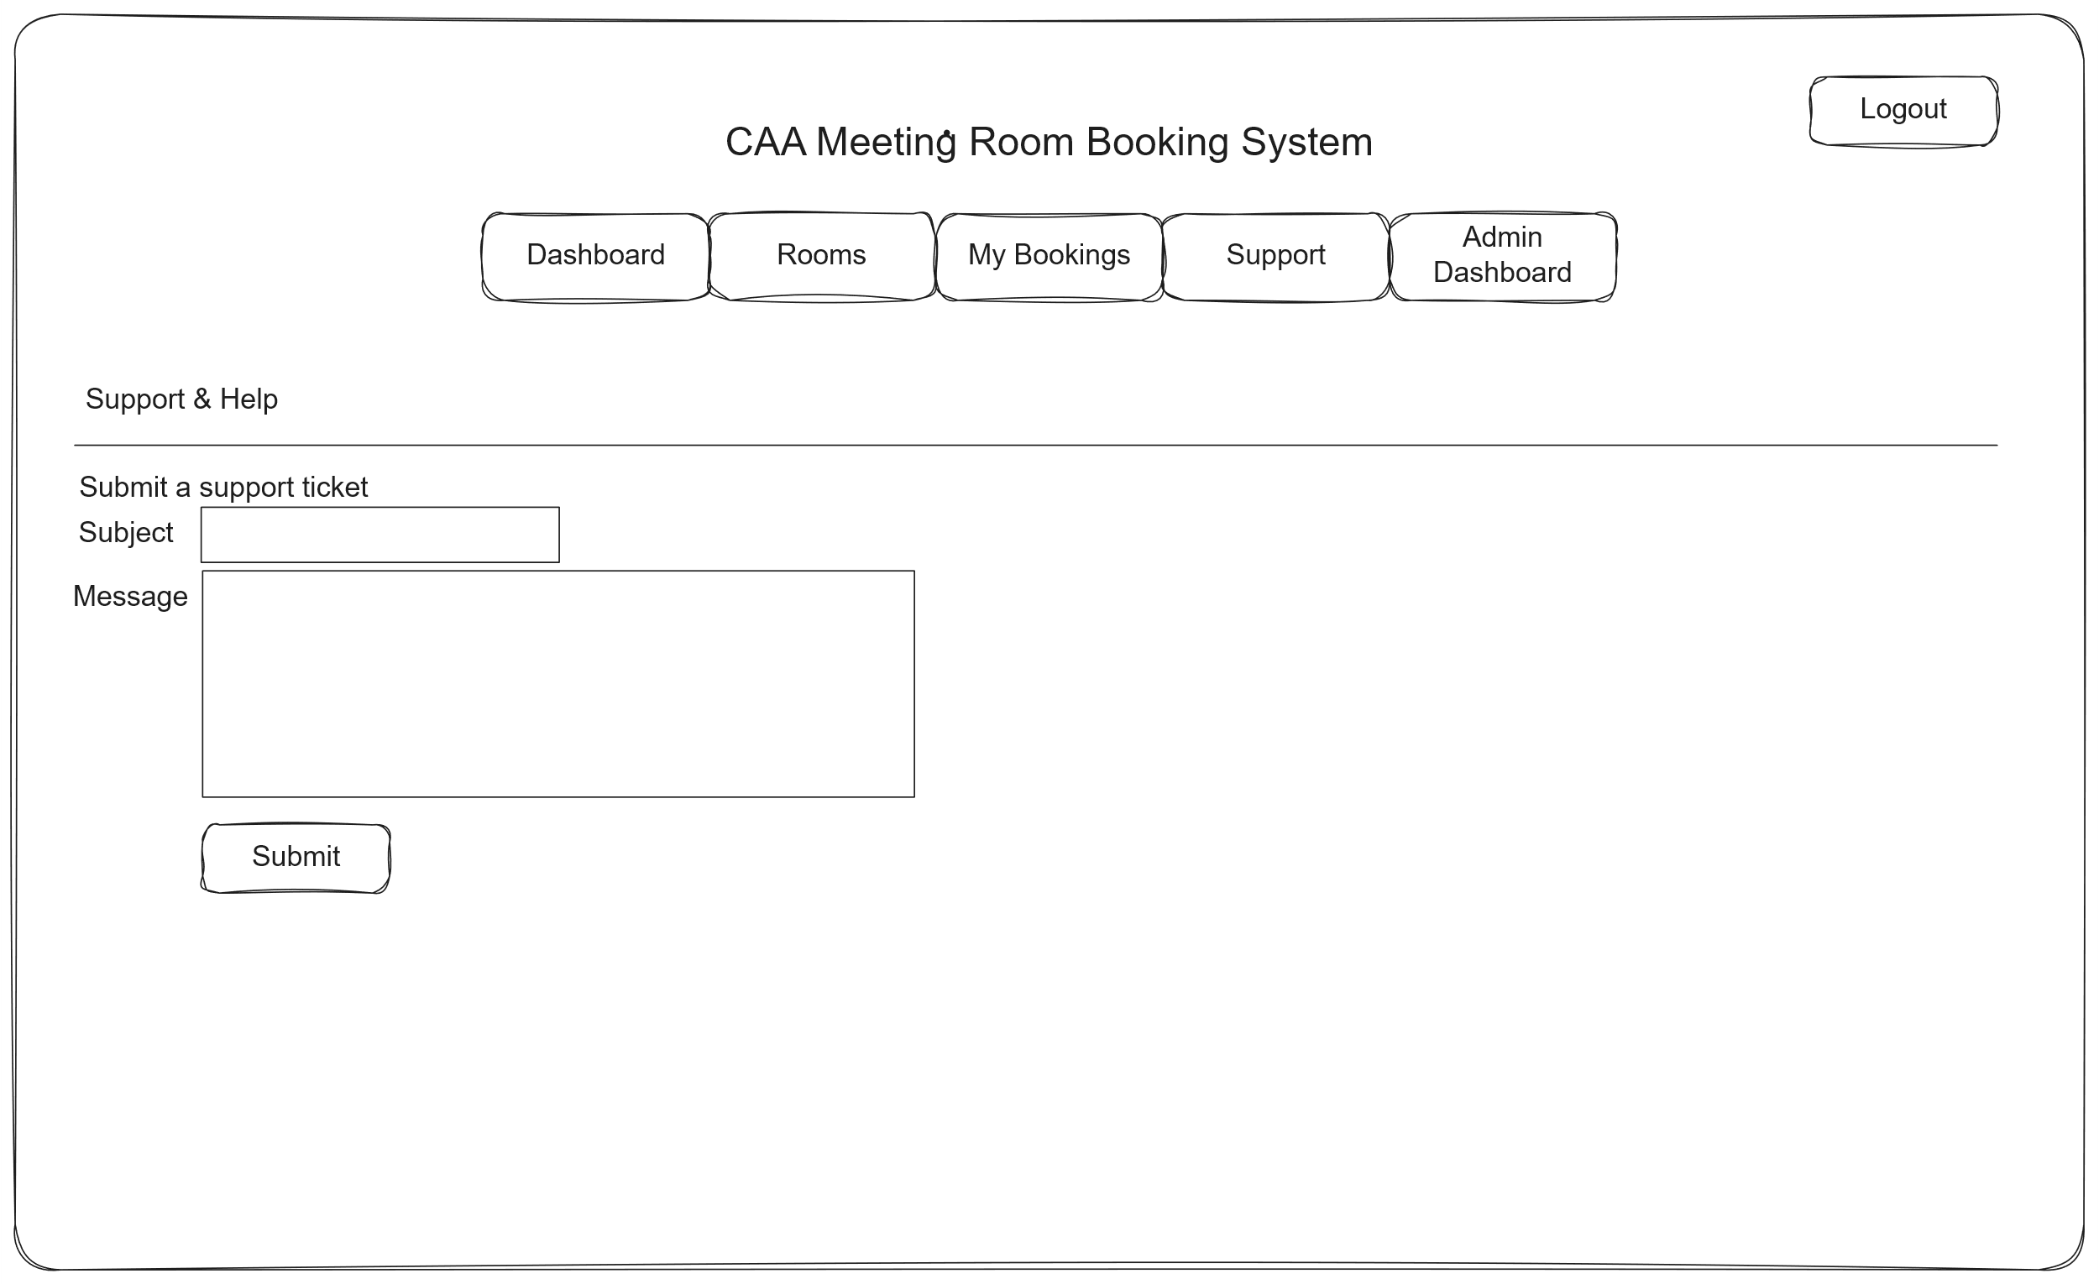

Admin dashboard
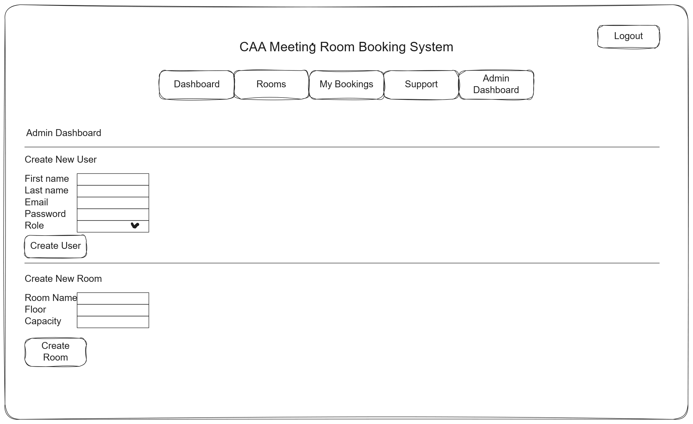

Data structure
Storing in SQL Database since it is the simplest and fastest way of querying through structured data, which this project fully is. NoSQL like MongoDB are options as well however the extra bloat and needing a server running with it just isn’t needed as this will be run as a demo so setting it up just isn’t worth it. Also, even though SQLite can have only one person write to db at a time due to it being a file, it’s a non-issue as said before only person will be using the system at a time as a demo. The big SQLite advantage is that it allows me to have a serverless database, meaning that I can develop it anywhere where I can download the db file instead of having to be in school to use the mssql one setup here or have to setup my own SQL server anywhere I want to develop. Also, due to it being a file it makes sure that the db is always up to date with codebase since instead of having a remote SQL server deployment everywhere I want to develop it, it is all synced via git inside the codebase so if I ever git clone it will have the latest db version.

Methods of Access
Method of Access | Type | Description
Find employee by ID | Direct | Retrieves a single employee using the primary key.
Find employee by email | Direct | Looks up a unique employee account via email during login.
Find room by ID | Direct | Loads a specific room record using its primary key.
Find booking by ID | Direct | Retrieves a single booking record for editing or cancellation.
Find admin by ID | Direct | Loads a specific admin record using the primary key.
Find support ticket by ID | Direct | Retrieves a specific ticket for viewing or updating.
Get all rooms | Indirect | Returns the full list of rooms for display or filtering.
Get bookings for employee | Indirect | Fetches all bookings associated with a specific user.
Get bookings for room | Indirect | Lists all bookings connected to a room for availability checks.
Search rooms by capacity/equipment/floor | Indirect | Retrieves rooms based on filters that may return multiple results.
Detect booking conflicts | Indirect | Checks for overlapping bookings in a room using time ranges.
Find available rooms | Indirect | Filters all rooms to determine which meet time and capacity constraints.
Get support tickets for employee | Indirect | Lists all support tickets submitted by a user.
Find admin handling tickets | Indirect | Retrieves all tickets assigned to a given admin.
Dashboard booking summaries | Indirect | Produces filtered lists like “today’s bookings” or “upcoming events”.

Database design - ERD
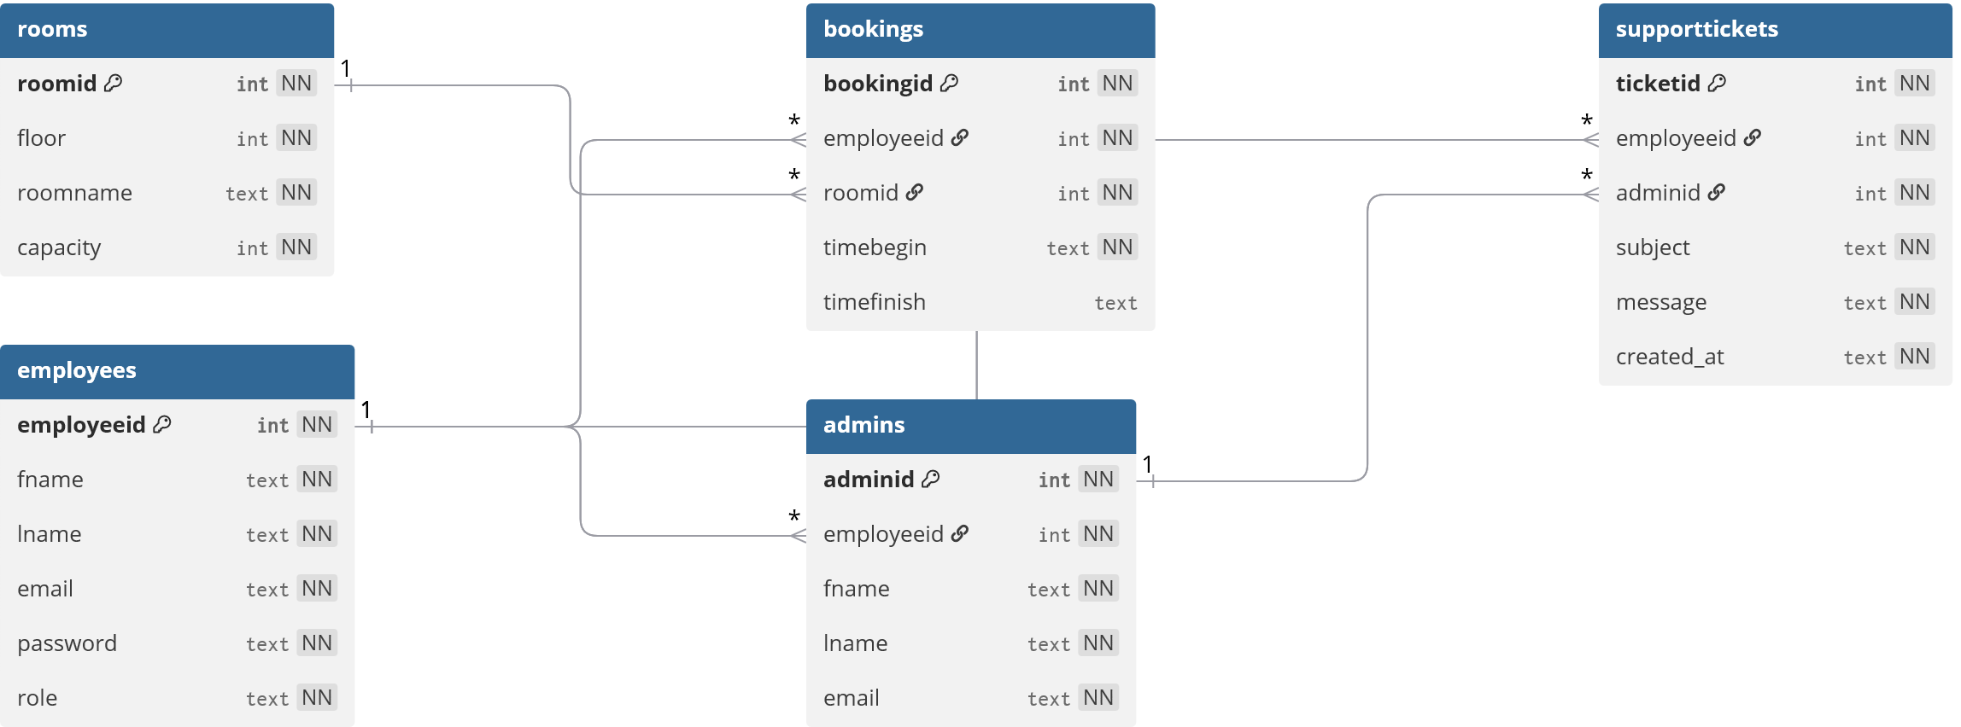

Data Dictionary

Employees
Field Name | Data Type | Short Description | Validation | Key
employeeid | int | Unique identifier for each employee | Primary Key, Auto Increment, Not Null, Unique | PK
fname | text | Employee's first name | Not Null
lname | text | Employee's last name | Not Null
email | text | Employee's email address | Not Null
password | text | Employee's password | Not Null
role | text | Employee's role in the company | Not Null, Default: 'staff', Check: role IN ('staff', 'senior', 'admin')

rooms
Field Name | Data Type | Short Description | Validation | Key
roomid | int | Unique identifier for each room | Primary Key, Auto Increment, Not Null, Unique | PK
floor | int | Floor number of the room | Not Null, Range Check: int in range 1 to 20
roomname | text | Name of the room | Not Null
capacity | int | Maximum number of people allowed | Not Null, Range Check: int in range 1 to 200

bookings
Field Name | Data Type | Short Description | Validation | Key
bookingId | int | Unique identifier for each booking | Primary Key, Auto Increment, Not Null, Unique | PK
employeeid | int | Reference to employee making booking | Not Null, FK -> employees.employeeid | FK
roomid | int | Reference to booked room | Not Null, FK -> rooms.roomid | FK
timebegin | text | Booking start time | Not Null, Default: CURRENT_TIMESTAMP
timefinish | text | Booking end time

admins
Field Name | Data Type | Short Description | Validation | Key
adminid | int | Unique identifier for each admin | Primary Key, Auto Increment, Not Null, Unique | PK
employeeid | int | Reference to employee associated | FK -> employees.employeeid | FK
fname | text | Admin's first name | Not Null
lname | text | Admin's last name | Not Null
email | text | Admin's email address | Not Null

supporttickets
Field Name | Data Type | Short Description | Validation | Key
ticketid | int | Unique identifier for each ticket | Primary Key, Auto Increment, Not Null, Unique | PK
employeeid | int | Reference to employee who submitted ticket | Not Null, FK -> employees.employeeid | FK
adminid | int | Reference to admin handling ticket | Not Null, FK -> admins.adminid | FK
subject | text | Subject of the support ticket | Not Null
message | text | Message content of the ticket | Not Null
created_at | text | Timestamp when ticket was created | Not Null, Default: CURRENT_TIMESTAMP

Validation

Validation for DB
Field Name | Database Validation | Application (Python) Validation | Error Handling (Try/Except or Others) | Notes/Reasoning
employeeid | Primary Key, Auto Increment, Not Null | Ensure IDs are positive integers | Catch ValueError if non-integer input provided | DB handles uniqueness and integrity automatically
fname | Not Null | Check string is not empty, length limits | Raise ValueError or custom exception for empty or too long names | Prevent empty names and excessive input
lname | Not Null | Same as fname | Same as fname
email | Not Null, Unique (if enforced) | Regex check for valid email format | Custom exception with helpful error message | Prevent invalid email input
password | Not Null | Minimum length, complexity (e.g., includes numbers, letters) | Raise exception if criteria not met | Improve security
role | Not Null, Default: 'staff', Check constraint for allowed values ('staff', 'senior', 'admin') | Validate value is within allowed roles | Raise ValueError if invalid role | Ensure role consistency
floor | Not Null, integer | Check integer and valid range (e.g., >=0) | Catch ValueError | Avoid invalid floor numbers
roomname | Not Null | Not empty, reasonable length | Raise exception | Prevent meaningless room names
capacity | Not Null, integer | Positive integer only | Raise ValueError | Avoid zero or negative capacity
timebegin | Not Null, Default CURRENT_TIMESTAMP | Validate date/time format, logical time (not past) | Manage parsing exceptions | Maintain valid booking time
timefinish | Nullable | Validate date/time format, must be after timebegin | Raise error if invalid or inconsistent | Ensure bookings end after they start
adminid | Foreign Key (admins.adminid), Not Null | Ensure admin exists in the system | Catch exceptions on missing admin | Referential integrity
subject | Not Null | Non-empty string check | Raise exception | Avoid empty tickets
message | Not Null | Non-empty string check | Raise exception | Ensure meaningful messages
created_at | Not Null, Default CURRENT_TIMESTAMP | Validate timestamp on creation | Manage exceptions if manually set | Track accurate ticket creation time

Validation inside the python codebase
Field Name | Python Validation Logic | Validation Libraries/Methods | Error Handling (Try/Except) | Notes/Reasoning
employeeid | Ensure input is integer and positive | int() casting, isinstance() check | ValueError catch if conversion fails | Avoid invalid IDs before DB insert
fname | Check not empty, check length (e.g., min 1, max 50) | String length checks | Raise ValueError for invalid input | Avoid blank or excessively long names
lname | Same as fname | Same | Same
email | Validate email format with regex | re module with regex pattern | Raise custom InvalidEmailError or ValueError | Prevent malformed emails
password | Minimum length (e.g., 8), check for mix of characters | Custom checks or libraries like passlib | Raise ValueError with descriptive message | Enforce password strength
role | Check if value in allowed set ['staff', 'senior', 'admin'] | Simple in operator | Raise ValueError for invalid role | Consistency with DB constraint
floor | Must be integer, positive or zero | int() casting | ValueError catch | Prevent invalid floor numbers
roomname | Not empty, reasonable length | String length checks | Raise ValueError | Ensure meaningful room names
capacity | Positive integer only | int() casting and > 0 check | ValueError catch | Avoid zero or negative capacities
timebegin | Validate datetime format, not in past | datetime.strptime(), compare with datetime.now() | ValueError and custom errors | Prevent invalid or illogical booking times
timefinish | Same as timebegin, plus ensure after timebegin | Same as above | Raise ValueError if timefinish ≤ timebegin | Logical booking durations
adminid | Ensure exists in system before assign | Database query or cache lookup | Raise LookupError or custom exception | Maintain foreign key consistency
subject | Not empty | String check | Raise ValueError | Avoid blank support tickets
message | Not empty | String check | Raise ValueError | Ensure ticket message has content
created_at | Validate datetime format if manually set | datetime.strptime() | ValueError catch | Mostly auto-set, but validated if manual input

Algorithms

User Authentication Algorithm
1. ALGORITHM authenticateUser(email, password)
2. BEGIN
3. user = findUserByEmail(email)
4. IF user EXISTS AND user.password = password THEN
5. createUserSession(user.employeeId, user.role)
6. RETURN success
7. ELSE
8. RETURN failure
9. END IF
10. END
11.

Room Booking Conflict Detection Algorithm
1. ALGORITHM checkBookingConflict(roomId, startTime, endTime)
2. BEGIN
3. conflictingBookings = findBookingsWhere(
4. booking.roomId = roomId AND
5. booking.startTime < endTime AND
6. booking.endTime > startTime
7. )
8.
9. IF conflictingBookings.count > 0 THEN
10. RETURN true // Conflict exists
11. ELSE
12. RETURN false // No conflict
13. END IF
14. END
15.

Booking Validation Algorithm
1. ALGORITHM validateBooking(roomId, startTime, endTime, userId)
2. BEGIN
3. // Check if room exists
4. room = findRoomById(roomId)
5. IF room NOT EXISTS THEN
6. RETURN error("Invalid room")
7. END IF
8.
9. // Validate time format and parse
10. TRY
11. parsedStartTime = parseDateTime(startTime)
12. parsedEndTime = parseDateTime(endTime)
13. CATCH dateTimeError
14. RETURN error("Invalid date/time format")
15. END TRY
16.
17. // Check if end time is after start time
18. IF parsedEndTime <= parsedStartTime THEN
19. RETURN error("End time must be after start time")
20. END IF
21.
22. // Check if booking is not in the past
23. currentTime = getCurrentDateTime()
24. IF parsedStartTime < currentTime THEN
25. RETURN error("Cannot create bookings in the past")
26. END IF
27.
28. // Check booking duration limit (8 hours max)
29. duration = parsedEndTime - parsedStartTime
30. durationHours = duration.toHours()
31. IF durationHours > 8 THEN
32. RETURN error("Booking duration cannot exceed 8 hours")
33. END IF
34.
35. // Check for scheduling conflicts
36. hasConflict = checkBookingConflict(roomId, startTime, endTime)
37. IF hasConflict THEN
38. RETURN error("Room is already booked for selected time")
39. END IF
40.
41. RETURN success
42. END
43.

User Creation Validation Algorithm
1. ALGORITHM validateNewUser(firstName, lastName, email, password, role)
2. BEGIN
3. // Check all fields are provided
4. IF firstName.isEmpty() OR lastName.isEmpty() OR
5. email.isEmpty() OR password.isEmpty() OR role.isEmpty() THEN
6. RETURN error("All fields are required")
7. END IF
8.
9. // Validate role
10. validRoles = ["staff", "senior", "admin"]
11. IF role NOT IN validRoles THEN
12. RETURN error("Invalid role selected")
13. END IF
14.
15. // Validate email domain
16. IF NOT email.endsWith("@caa.co.uk") THEN
17. RETURN error("Email must be a valid @caa.co.uk address")
18. END IF
19.
20. // Validate password length
21. IF password.length < 8 THEN
22. RETURN error("Password must be at least 8 characters long")
23. END IF
24.
25. // Validate name lengths
26. IF firstName.length < 2 OR lastName.length < 2 THEN
27. RETURN error("Names must be at least 2 characters long")
28. END IF
29.
30. // Check for existing email
31. existingUser = findUserByEmail(email)
32. IF existingUser EXISTS THEN
33. RETURN error("Email already exists")
34. END IF
35.
36. RETURN success
37. END
38.

Room Creation Validation Algorithm
1. ALGORITHM validateNewRoom(roomName, floor, capacity)
2. BEGIN
3. // Check all fields are provided
4. IF roomName.isEmpty() OR floor.isEmpty() OR capacity.isEmpty() THEN
5. RETURN error("All fields are required")
6. END IF
7.
8. // Validate room name
9. IF roomName.length < 1 THEN
10. RETURN error("Room name cannot be empty")
11. END IF
12.
13. // Validate floor is valid integer
14. TRY
15. floorNumber = parseInt(floor)
16. CATCH parseError
17. RETURN error("Floor must be a valid number")
18. END TRY
19.
20. // Validate floor is non-negative
21. IF floorNumber < 0 THEN
22. RETURN error("Floor must be 0 or greater")
23. END IF
24.
25. // Validate capacity is valid integer
26. TRY
27. capacityNumber = parseInt(capacity)
28. CATCH parseError
29. RETURN error("Capacity must be a valid number")
30. END TRY
31.
32. // Validate capacity limits
33. IF capacityNumber <= 0 THEN
34. RETURN error("Capacity must be greater than 0")
35. END IF
36.
37. IF capacityNumber > 200 THEN
38. RETURN error("Capacity cannot exceed 200")
39. END IF
40.
41. // Check for duplicate room on same floor
42. existingRoom = findRoomByFloorAndName(floorNumber, roomName)
43. IF existingRoom EXISTS THEN
44. RETURN error("Room with this name already exists on this floor")
45. END IF
46.
47. RETURN success
48. END
49.

Authorization Check Algorithm
1. ALGORITHM checkUserAuthorization(userId, requiredRole, resourceOwnerId)
2. BEGIN
3. user = findUserById(userId)
4. IF user NOT EXISTS THEN
5. RETURN false
6. END IF
7.
8. // Admin can access everything
9. IF user.role = "admin" THEN
10. RETURN true
11. END IF
12.
13. // Check if user has required role level
14. roleHierarchy = ["staff": 1, "senior": 2, "admin": 3]
15. userLevel = roleHierarchy[user.role]
16. requiredLevel = roleHierarchy[requiredRole]
17.
18. IF userLevel >= requiredLevel THEN
19. RETURN true
20. END IF
21.
22. // Check if user owns the resource
23. IF resourceOwnerId IS PROVIDED AND user.id = resourceOwnerId THEN
24. RETURN true
25. END IF
26.
27. RETURN false
28. END
29.

Support Ticket Assignment Algorithm
1. ALGORITHM assignSupportTicket(employeeId, subject, message)
2. BEGIN
3. // Find available admin
4. availableAdmin = findFirstAdmin()
5. IF availableAdmin NOT EXISTS THEN
6. RETURN error("No admin available")
7. END IF
8.
9. // Create support ticket
10. ticket = createSupportTicket(
11. employeeId: employeeId,
12. adminId: availableAdmin.id,
13. subject: subject,
14. message: message,
15. createdAt: getCurrentDateTime()
16. )
17.
18. saveTicket(ticket)
19. RETURN success
20. END
21.

Room Availability Search Algorithm
1. ALGORITHM findAvailableRooms(startTime, endTime, minimumCapacity)
2. BEGIN
3. allRooms = getAllRooms()
4. availableRooms = []
5.
6. FOR each room IN allRooms DO
7. // Check capacity requirement
8. IF minimumCapacity IS PROVIDED AND room.capacity < minimumCapacity THEN
9. CONTINUE
10. END IF
11.
12. // Check for booking conflicts
13. hasConflict = checkBookingConflict(room.id, startTime, endTime)
14. IF NOT hasConflict THEN
15. availableRooms.add(room)
16. END IF
17. END FOR
18.
19. RETURN availableRooms
20. END
21.

User Session Management Algorithm
1. ALGORITHM manageUserSession(sessionData)
2. BEGIN
3. // Check if user is logged in
4. IF sessionData.employeeId NOT EXISTS THEN
5. RETURN false
6. END IF
7.
8. // Validate session user still exists
9. user = findUserById(sessionData.employeeId)
10. IF user NOT EXISTS THEN
11. clearSession()
12. RETURN false
13. END IF
14.
15. // Update session with current user data
16. sessionData.role = user.role
17. sessionData.lastActivity = getCurrentDateTime()
18.
19. RETURN true
20. END
21.

Booking Cancellation Algorithm
1. ALGORITHM cancelBooking(bookingId, userId, userRole)
2. BEGIN
3. booking = findBookingById(bookingId)
4. IF booking NOT EXISTS THEN
5. RETURN error("Booking not found")
6. END IF
7.
8. // Check authorization
9. canCancel = (booking.employeeId = userId) OR (userRole = "admin")
10. IF NOT canCancel THEN
11. RETURN error("You can only cancel your own bookings")
12. END IF
13.
14. // Perform cancellation
15. deleteBooking(bookingId)
16. RETURN success
17. END
18.
19.

